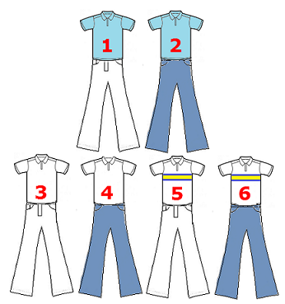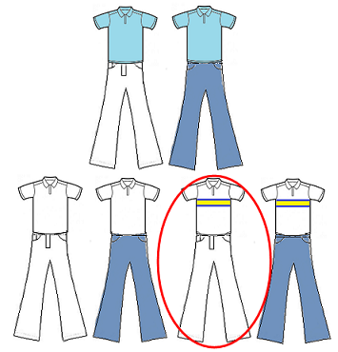

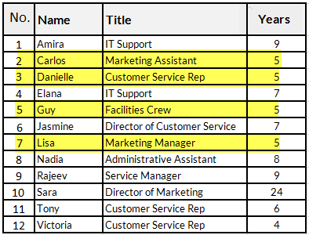

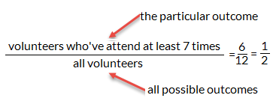

the specific outcome

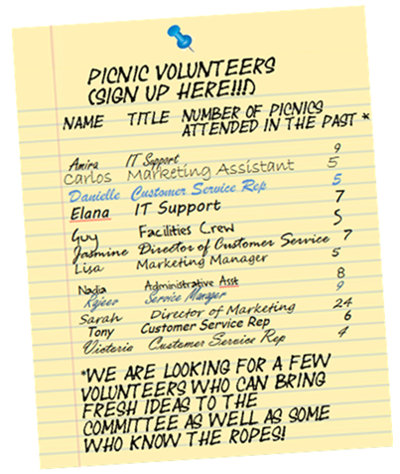

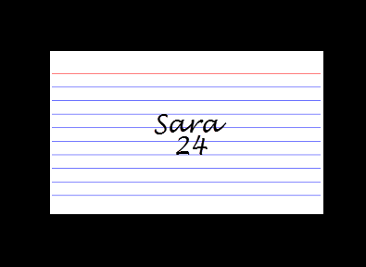

Less likely to happen

More likely to happen

0% 50% 100%

Will not happen

Will happen

Equally likely that it will happen or will not happen

16.67%

Less likely to happen

More likely to happen

0% 50% 100%

Will not happen

Will happen

Equally likely that it will happen or will not happen

30%

Less likely to happen

More likely to happen

0% 50% 100%

Will not happen

Will happen

Equally likely that it will happen or will not happen

43%

Less likely to happen

More likely to happen

0% 50% 100%

Will not happen

Equally likely that it will happen or will not happen

Will happen

14.29%

Less likely to happen

More likely to happen

0% 50% 100%

Will not happen

Will happen

Equally likely that it will happen or will not happen

85.71%

Less likely to happen

More likely to happen

0% 50% 100%

Will not happen

Will happen

Equally likely that it will happen or will not happen

12.5%

Less likely to happen

More likely to happen

0% 50% 100%

Will not happen

Will happen

Equally likely that it will happen or will not happen

9.09%

Will not happen

Will happen

Equally likely that it will happen or will not happen

0% 50% 100%

Less likely to happen

More likely to happen

Less likely to happen

More likely to happen

0% 50% 100%

Will not happen

Will happen

Equally likely that it will happen or will not happen

57.14%

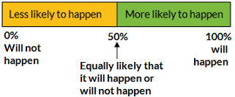

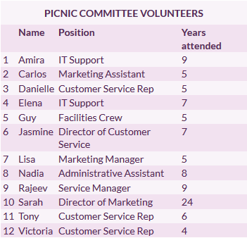

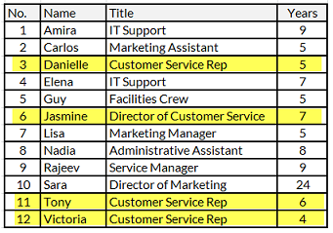

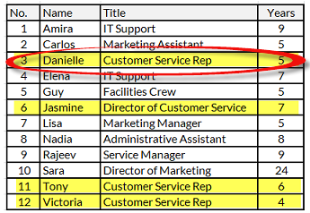

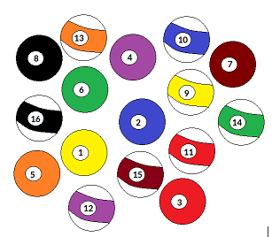

Guided Practice Tables

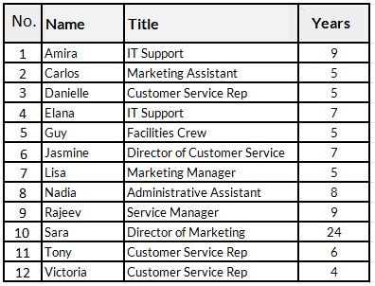





Word table:

|  |  |  |  |
| --- | --- | --- | --- |
|  | **Name** | **Title** | **Years** |
| 1 | Amira | IT Support | 9 |
| 2 | Carlos | Marketing Assistant | 5 |
| 3 | Danielle | Customer Service Rep | 5 |
| 4 | Elana | IT Support | 7 |
| 5 | Guy | Facilities Crew | 5 |
| 6 | Jasmine | Director of Customer Service | 7 |
| 7 | Lisa | Marketing Manager | 5 |
| 8 | Nadia | Administrative Assistant | 8 |
| 9 | Rajeev | Service Manager | 9 |
| 10 | Sara | Director of Marketing | 24 |
| 11 | Tony | Customer Service Rep | 6 |
| 12 | Victoria | Customer Service Rep | 4 |



Refresher 8.4 Tables

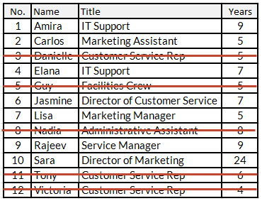

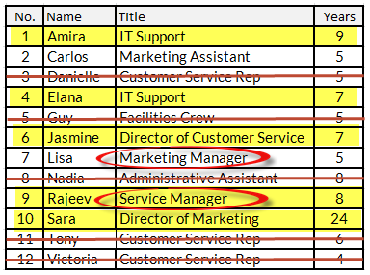

P(Danielle | customer service)

“assuming that”

Refresher 8.3 Tables:

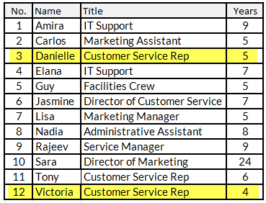

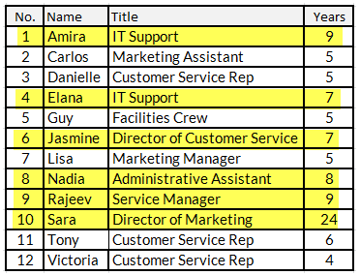

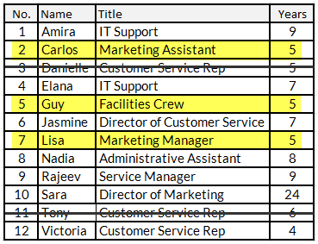

Refresher 8.5 Tables:

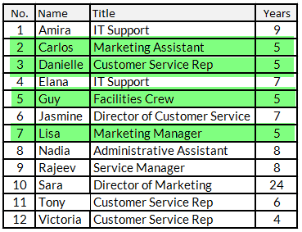

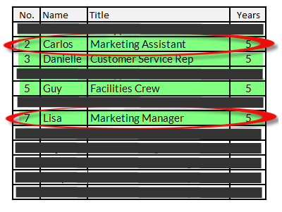

Refresher 8.6 Tables:

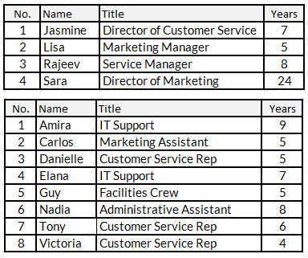

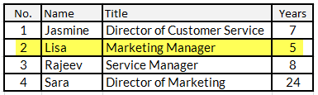

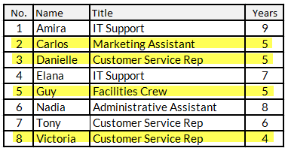

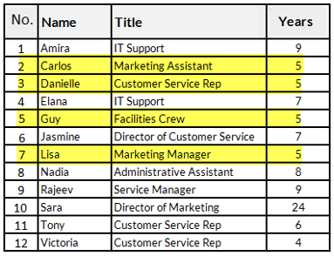

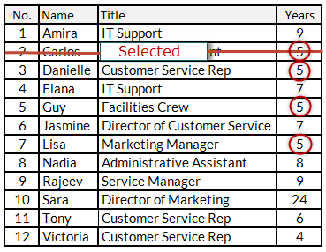

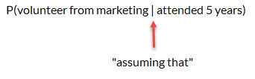

times

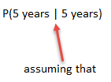

times

times